Name: V.Siri Chandana
Roll No: 2520030609
Section:2
Subject:OS
SKILL Component:
Skill 2:
1.
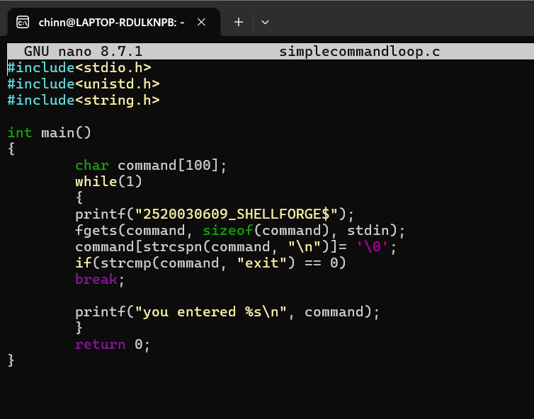

Output:
